Tachometer Gauge Digital with Setup – s550 Specific - CGEA1.3

Functional Description
The purpose of the Digital Tachometer Gauge Setup feature is to provide a selectable menu to the user. The user can choose to display digital RPM value, the selected gear position or nothing (blank) in the predetermined location in the cluster display. This menu is available on the LX cluster regardless of the transmission type.

The expectation is that the digital tachometer gauge is always paired with an analog style tachometer gauge. This poses unique challenges, since the 2 tachometers need to match. Our design allows the 2 tachometers to match as best as possible. The only expected differences are due to analog pointer calibration and hysteresis of the stepper motor. The allowed calibration error is +/- 1.0 angular degrees. Typical stepper hysteresis error is 0.7 angular degrees. (Note the hysteresis will only be present when the pointer is moving in the opposite direction from which it was calibrated – either ascending or descending – and will exist only until the direction changes again). This gives a worst possible error of 1.7 angular degrees. The nominal error is closer to 0 angular degrees.

Although the LX cluster is a completely virtual cluster, we are designing the digital tachometer to also work with a stepper motor tachometer.

The key to this design is that the digital tacho is driven by the internal commanded stepper motor target. Typical stepper motors are designed to have 3600 steps (counts), where every 12 steps is 1 angular degree. We will use a reverse lookup table to determine indicated pointer tach based on driver counts. This makes the transient cases look best. (i.e. when accelerating/decelerating sharply) as compared to attempting to drive to the pointer target.

The digital display is further filtered by update rate (typical 200ms), an output hysteresis and rounding. The program has requested rounding be applied to nearest tens digit for digital tach. The analog tach has a hysteresis of 20 RPM, but for the digital tach, we are using a hysteresis of 10 RPM. Thus, we are using the tachometer gauge indication before hysteresis is applied from the analog tachometer STSS.

The Digital Tachometer Gauge correlates the internal commanded stepper motor target from the analog Tachometer Gauge STSS and the Ignition_Status to generate a digital display of the vehicle’s indicated engine speed. The gear display is based on the “Gear Selection Function with primary ePRNDL – CGEA1.3” STSS.

Interfaces

Interface Context Diagram (I/O Block Diagram)
Digital Tachometer Display with Setup Context Diagram

Inputs

IR-REQ-302819/A-Internal
- Tachometer_Gauge_No_Hysteresis (From Tachometer Gauge STSS) - Position of pointer for Analog gauge displaying the vehicle’s indicated engine speed. This output is used to physically drive the tachometer pointer to the correct indication before the 20 RPM hysteresis is applied.
- Tach_RedLine_Cfg
- M/C Switch Event
- Gear_Select_MC_Status_Flag or Manual_Gear_MC_Status_Flag – Please refer to the “Gear Selection Function with Primary ePRNDL – CGEA1.3” STSS for more detail.
- Operational_Mode

Outputs

IR-REQ-302820/A-Internal
- Digital_Tacho_Numeric_MC – Numeric display of the vehicle’s indicated speed.
- Digital_Tacho_Setting_MC – Selection of tachometer display from the settings menu.

Function/Performance

F-REQ-302824/A-Operational Modes

Mode | Differentiating Vehicle Conditions
Sleep Mode | Digital Tachometer Gauge/Menu OFF
Limited Mode | Digital Tachometer Gauge/Menu OFF
Normal Mode | Digital Tachometer Gauge/Menu On
Crank Mode | Digital Tachometer Gauge/Menu On

Voltage Levels
Refer to the Cluster Features Table located in the Operational Modes and Voltage Range Strategies Section of this SPSS.

Human-Machine Interface

Visual

Indicator Graphics / Display Format
Refer to Graphics Section in the Master Document Section in this SPSS.
Example of digital RPM shown below.
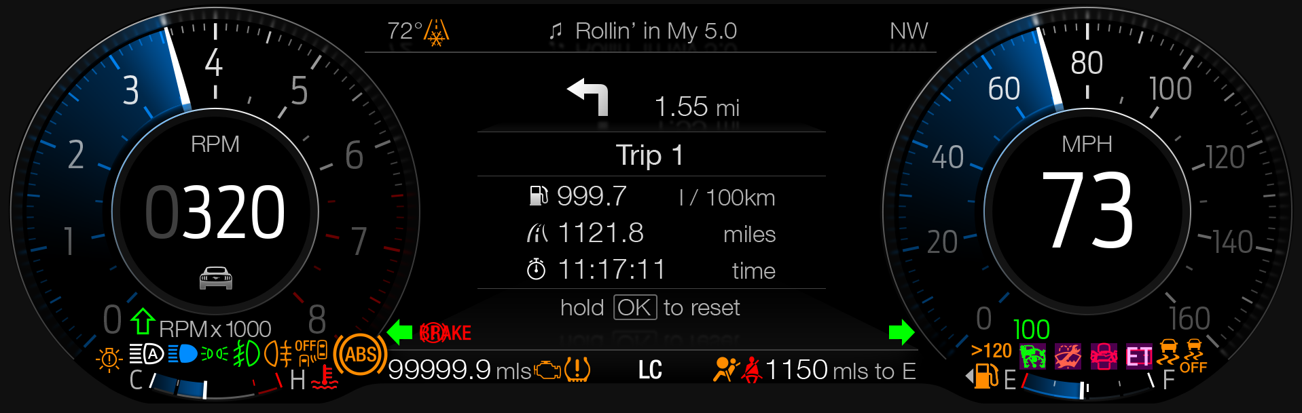

Example of menu structure:
menu level 1 |  | menu level 2 |  | menu level 3
Display Setup > | t#$ | title: Display Setup | t#$
 |  | Tachometer Display > | t#$ | title: Tachometer Display
 |  |  |  | # Digital Tachometer
 |  |  |  | # Gear
 |  |  |  | # None

Indicator Color Coordinates
Refer to section COLOR & ILLUMINATION REQUIREMENTS (GRAPHICS) in the Master Document Section in this SPSS.

Indicator Characteristics
Refer to the "Tachometer Transfer Function.xls" file, which is located in the same folder as this SPSS File.

Audio
None.

Switch Control Logic
Consumer access to the Digital Tachometer menu shall be as specified in the message center basic functionality display as specified in Message Center X Display_Y Button Interface Section, where X and Y are appropriate values in this document.

System Accuracy

PFM-REQ-302817/A-Digital Tachometer Display Response Time
Digital Tachometer shall indicate the position of the analog Tachometer to the desired display format precision within 500ms of a change in position.

PFM-REQ-302818/A-Digital Tachometer Display Update Rate
Shall update digital tachometer display every DIG_TACH_UPDATE_RATE ms

Operation: Performance and Functional

Subsystem Algorithm Flowchart / State Diagram

F-REQ-302813/A-Digital Tachometer Diagnostic Configuration Flowchart

F-REQ-302814/A-Subsystem Flowchart

Subsystem Flowchart (continued)

F-REQ-302815/A-Flowchart – Digital Tachometer Setting Menu

F-REQ-302816/A-Digital_Tacho_Setting_MC and next states based upon M/C Switch Event

Digital_Tacho_Setting_MC | Digital Tachometer Menu | M/C Switch Event to change setting | Next  Digital_Tacho_Setting_MC
RPM (0x1) |  | True | 0x2 if Gear is selected  0x0 if None is selected
Gear (0x2) |  | True | 0x1 if RPM is selected  0x0 if None is selected
None (0x0) |  | True | 0x1 if RPM is selected  0x2 if Gear is selected

Operation Description (supports algorithm flowchart /state diagram)

F-REQ-302811/A-Digital Tachometer Gauge at 0 RPM
The digital tachometer gauge shall indicate “0” RPM when analog tachometer gauge is at the “Rest Position”.

F-REQ-302812/A-DIG_TACHO_CFG Configuration
Since the Digital Tachometer menu is now being displayed on all S550 LX clusters (manual as well as automatic transmission), the Dig_Tacho_Cfg is a don’t care, hence not required.

Digital Tachometer Gauge Filtering

F-REQ-302810/A-Digital Tachometer Programmable Display Update Rate
The Digital Tachometer Gauge shall support a programmable display update rate, denoted as DIG_TACH_UPDATE_RATE

Impact of Changed Hysteresis Values other than recommended values
A change in the values used for the hysteresis values to other than those recommended in the Memory Storage section need to consider the impact of the new values on the following:

F-REQ-302807/A-Correlation of Digital Tach and Tachometer Pointer
Correlation of the Digital Tach Displayed value and the Tachometer Pointer value. Larger hysteresis values will increase the probability of a mismatch between the two.

Color of Digital Tachometer

F-REQ-302809/A-Digital Tachometer RPM Red Color
For the Digital RPM: When above the the tach soft cutout point for the engine, the color is changed to red.

F-REQ-302808/A-Range Definition for Digital Tach Color Red
The digital tach color is changed to red when the tachometer gauge indication is in the range defined by the DE03 parameter Tach_Redline_Cfg.
Example below: (Note Digital RPM and Tachometer Comet Tail turn red at same time)
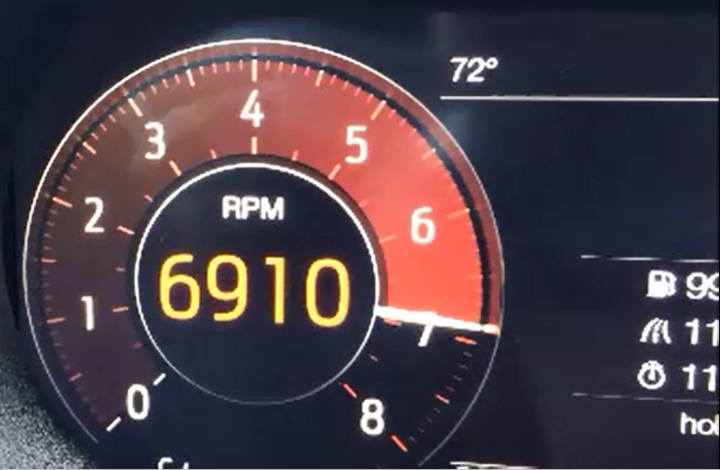

FS-REQ-302825/A;1-Function Safety Classification (EMC)
B

NVM-REQ-302821/A-Memory Storage

Parameter Name | Description | Value at  Battery Connect | Value at  Module Wake-up
Current_Indicated_Analog_Tach | Indicated engine speed of analog tachometer at the particular instant in time. Obtained from a lookup table of internal stepper motor commanded driver counts to speed. This is applied before the 20 RPM hysteresis form the Tachometer Gauge STSS. | 0 | 0
Prev_Cur_Ind_Analog_Tach | Previous value for Current_Indicated_Analog_Tach | 0 | 0
Digital_Tacho_Numeric_MC | Filtered display that shows digital tachometer to the driver. In units of RPM. | 0 | 0
Digital_Tacho_Setting_MC | Displayed setting of the Digital Tachometer setting menu in the Message Center | Gear (0x2)  (Default display is gear position) | Do Not Init
DIG_TACH_UPDATE_RATE | Controls refresh rate of digital tachometer displayed value in ms. Selectable 100ms – 1000ms in 50ms increments. Default is 150ms. | Use Stored Value | Use Stored Value
Inc_Dig_Speed_Hys_RPM | Hysteresis for an increasing engine speed displayed in RPM. The value is in units of RPM with a resolution of 1 and a range of 0 to 50. Default value is 10. | Program Specific Value | Do Not Init
Dec_Dig_Speed_Hys_RPM | Hysteresis for a decreasing engine speed displayed in RPM. The value is in units of RPM with a resolution of 1 and a range of 0 to 50. Default value is 10. | Program Specific Value | Do Not Init
Disp_Zero_Threshold_RPM | Threshold for a decreasing engine speed to display zero RPM. The value is in units of RPM with a resolution of 1 and a range of 0 to 50. This value must be greater than or equal to Dec_Dig_Speed_Hys_RPM.  Default value is 10. | Program Specific Value | Do Not Init
Tach_RedLine_Cfg | Encoded indicator of feature presence controlled via CAN at EOL at VO plant. | Use Stored Value | Use Stored Value
Gear_Select_MC_Status_Flag or  Manual_Gear_MC_Status_Flag | Refer to the “Gear Selection Function with Primary ePRNDL – CGEA1.3” STSS for init values.
Operational_Mode | 4 state indicator for cluster operational mode | Limited | Limited or Normal or Crank

Prove Out
No

Reconfigurable Telltale
No

Message Center Msg
No

Error Handling
None. (Note an error in analog tachometer will cause digital tachometer to be 0)

Missing Message Strategy
None

Invalid Message Strategy
None

Diagnostics

Self Test
None

Engineering Test Mode
Reference section “Dealer / Engineering Test Mode (ETM)”

Part II Performance

Supported Diagnostic Trouble Codes (DTCs)

DTC | Description
None

DCR-REQ-302823/A-DID DE03

Bit(s) | State: Description | "0" | “1” | “2” | "3" | Default | Comments/  Information
2 | Tach_RedLine | No Redline | Range 1 | Range 2 | Range 3 | 0x1 (Range 1) | Used by IPCs that have virtual tachometers.  This parameter defined in Tachometer Gauge – CGEA 1.3 STSS.

Reference Specification
IS-0046 INSTRUMENTATION MATERIAL RESISTANCE TO CLEANING
IS-0052 OPERATING VOLTAGES - FUNCTIONAL/PERFORMANCE
IS-0069 FUNCTIONAL IMPORTANCE CLASS
IS-0324 WINDSHIELD & OTHER REFLECTIONS

IL-0017 TELLTALE AND INTERIOR ILLUMINATION COLOR
IL-0021 CRAFTSMANSHIP - DISPLAYS
IL-0023 CLARITY/LEGIBILITY/READABILITY
IL-0025 INTERIOR ILLUMINATION INTENSITY
IL -0027 VISUAL CONTRAST
IL -0043 OPERATIONAL ENVIRONMENT FUNCTIONALITY
IL -0045 COLOR
IL -0048 ILLUMINATION ACCEPTABILITY

03-0661 PLACEMENT: CONTROL AND DISPLAY LOCATIONS
03-0662 PLACEMENT: LOGICAL GROUPING FUNCTION AND USAGE
03-0664 PLACEMENT: DOWN VISION TO COMPONENTS WITH HIGH VISUAL DEMAND
03-0665 PLACEMENT: EXPECTED LOCATIONS OF CONTROLS AND DISPLAYS VDS
03-0670 INTERIOR VISIBILITY
03-0671 INTERIOR VISIBILITY: REFLECTIONS FROM COMPONENTS & SURFACES
03-0672 INTERIOR VISIBILITY: REFLECTIONS IN DISPLAYS
03-0673 INTERIOR VISIBILITY: VISUAL OBSCURATIONS
03-0674 INTERIOR VISIBILITY: ILLUMINATION CONTROLS / DISPLAYS
03-0675 INTERIOR VISIBILITY: VEILING GLARE
03-0677 INTERIOR VISIBILITY: SUNLIGHT WASHOUT
03-0681 IDENTIFICATION: CHARACTER AND SYMBOL SIZE

Revision History
SPSS Module Revision History

Revision Level | Name | Change Description | Date
1.0 | S. Watkins | Initial release | 3/11/2016
1.1 | S. Watkins | After looking at simulations with vehicle data, it was decided that an update rate of 200ms would look better than 400ms. | 3/16/2016
2.0 | S. Watkins | It has been decided to have the redline behavior in the normal Tachometer extended to the digital RPM display as well. Thus, adding in the Tach_Redline_Cfg parameter to match this up with the Comet_Tail_Animation_Speed_Tach - s550 specific - CGEA 1.3 STSS.  - Section 1.2.1 – Added Tach_Redline_Cfg  - Section 1.2.2 – Added Tach_Redline_Cfg  - Section 1.3.5.1, Figure 2, added Tach_Redline_Cfg  - Section 1.3.5.2.2 – Added section with description of color change.  - Section 1.3.5.4 – Added Tach_Redline_Cfg  - Section 1.5.3 – Added Tach_Redline | 8/19/2016
2.1 | S. Watkins | Request from Keith Daugherty to change the refresh rate from 200ms to 150ms.  - Updated Section 1.3.5.4, parameter default for DIG_TACH_UPDATE_RATE changed to 150ms. | 10/13/2016
2.2 | V. Patel | Request from S550 team to expand the menu to allow the user to choose between Digital Tacho, Gear and None (blank) display for the pre-determined area. All updates are in red.  DI CC approval: 5/18/2017  Section 1.1: Updated functional description to add that the new expanded menu is available on all vehicles with LX clusters (manual and auto trans)  Section 1.2.1, 1.2.2:  Added inputs required to display selected gear position if chosen by the user from the menu.  Also changed the “OK Switch Press” input to “M/C Switch Press” input to be consisten across other requirements.  Also struck out Dig_Tacho_Cfg parameter since it is not required anymore.  Section 1.3.3.1.1: Updated reference menu structure to show the expanded menu from one item to 3 items.  Section 1.3.5.1  Figure 2: Deleted the Digital Tachometer config parameter processing.  Figure 3: Modified one decision diamond (in red) to show updated value of RPM setting in the menu.  Figure 4: Developed new flowchart that continues from figure 3, processing the other two menu items.  Figure 5: Updated flowchart to reflect new expanded menu.  Table 1.0: Updated matrix to show the expanded menu states and next selection.  Section 1.3.5.4: Updated table to add inputs required for gear selection display.  Section 1.5.3: Struck through the Digital Tachometer feature configuration parameter since it is not required anymore for this feature. | 6/27/2017
2.3 | A. Mishra | Initial VSEM RM Revision Release | 03/26/2018

